Hawassa University – IoT

Faculty of Informatics

Department of Information System

Fundamentals of Programming in C++

***Lab Exercise 2***

* + - 1. Write a C++ program that prints out the following menu for a game (include the line of asterisks (*) on top and bottom):

***************************************************

Welcome!

Please choose a number from the following options:

1. Play the game!

2. Demo the game!

3. Exit

***************************************************

1. Write a temperature conversion program that gives the user the option of converting a value of temperature to Celsius and Fahrenheit scales of temperature using **switch case** and **if-else** statement. (**hint: °F = (°C × 9/5) + 32, °C = (°F-32)* 5/9**)

**Output:**

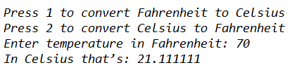

1. Write a program that takes balance of a user’s account as input. It should then ask the user how much amount he wants to withdraw from his account. The program should take this amount as input and deduct from the balance. Similarly it should ask the user how much amount he wants to deposit in his account. It should take this amount as input and add to the balance. The program shall display the new balance after amount has been withdrawn and deposited.

**Output:**

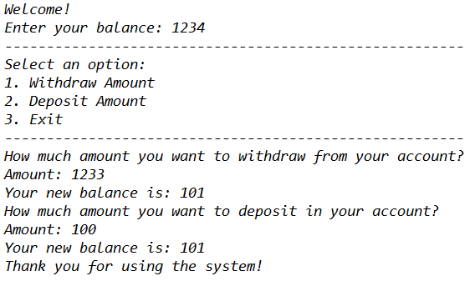

**Note:** Your program should have a check on balance and amount being withdrawn. Amounts greater than balance cannot be withdrawn i.e. balance cannot be negative.

1. Write a program which takes two numbers as input from user and determines which is the larger of the two numbers. The Program should also tell which of the entered numbers is even or odd.

**Output:**

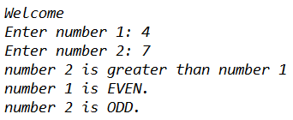

1. You need to design a calculator that performs four basic arithmetic operations. You will write a program that takes two numbers as input from the user. It then displays a list of arithmetic operations. The user selects one operation and the program displays the result of the corresponding operation. The program should also display which of the two input numbers is greater and which is smaller. Use do-while loop. Interaction with the program might look like the following:

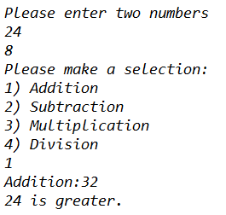

1. Write a program that takes marks of 10 students as input. It calculates the class average and displays it on the screen. Interaction with the program might look like this. Use while loop.

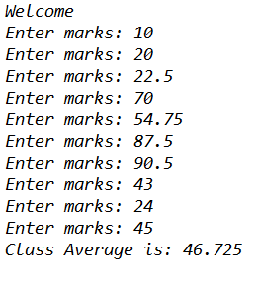

1. Write a program that calculates and prints the sum of the even integers from 2 to user_defined_limit and product of odd integers from 1 to user_defined_limit. Use a do-while loop that asks the user whether the program should be terminated or not. Also maintain a count as to how many times the user ran the do-while loop.
2. What is the output of the program below?

#include <iostream.h>

int main()

{

int n = 3;

while (n >= 0)

{

cout << n * n << endl;

--n;

}

cout << n << endl;

while (n < 4)

cout << ++n << endl;

cout << n << endl;

while (n >= 0)

cout << (n /= 2) << endl;

return 0;

}

1. Write a C++ program that takes a float number then convert it to integer with different ways.
2. Write a program to compute grade of students using if else adder. The grades are assigned as followed:

**Marks Grade**

1. marks<50 F
2. 50≤marks< 60 C
3. 60≤marks<70 B
4. 70≤marks<80 B+
5. 80≤marks<90 A
6. 90≤mars≤ 100 A+
7. Write a C++ program to print the even numbers from 10 to 0 using for loop?
8. Write a C++ program asks the user to enter 5 characters using for loop, if the user enters 'n' exit the loop.
9. Write a C++ program to print numbers from 10 to 0 using for loop, while loop and do---while loop except the number 5?
10. Write a C++ program that reads a student mark and print the following:

a. “Success” if student mark is greater than or equal 50.

b. “Fail” otherwise.

1. Write a program that inputs a character code and print its equivalent from the table below

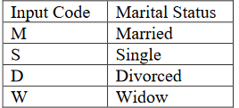

1. Write a program that inputs a student mark and outputs the corresponding rank, where ranks are as follows:

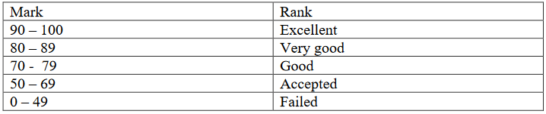

1. Write a program to find whether a character is consonant or vowel using **switch** statement.